November 2021
Due to an increase in the Covid 19 rate the hospital has taken the wise decision not to allow the League to hold their winter draw. The committee thought of several ways we could hold it but not on hospital grounds but to be safe it would be cancelled it’s a great disappointment to so many people especially the volunteers who were looking forward to helping.
WERE ON THE MOVE
We hope that very soon our new base on level 4 will be ready. The hospital estimate that it will be ready by the end of March 2022.
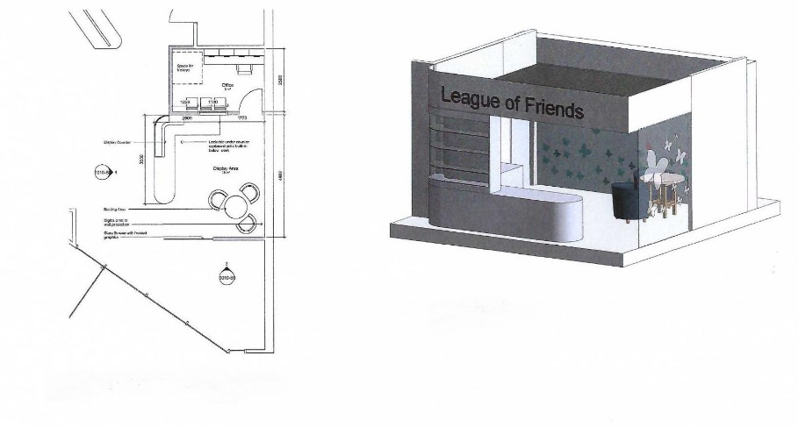
SUPPORT TO THE HOSPITAL
During 2009, the League was able to donate £1.72m to the new Horizon Centre – our centre for Research, training and Digital advancement. In 1967 The League provided funds for a building and equipping an Intensive Care Unit at Torbay Hospital. However in 2013 plans were made to build a brand new unit at a cost of £14m, which included specialised ICU equipment. The League was able to provide the £1.6m required to equip the 14 bays in the new Unit with the most modern and state of the art equipment in time for the opening in 2017. In 2019 The League was able to donate £1.3m to provide 34 new high definition endoscopes and three video processing units to re-equip the busy Endoscopy Department which undertakes some 11,000 procedures each year. Again, this was the League its long term commitment for a vital service having bought the original equipment that started the Endoscopy Services in the 1980’s. Please do not think that we only fund large projects- we listen to requests from the Hospital from all Departments and they choose what items they feel are most needed by them, which could be funded out of NHS budgets
MEMBERSHIP
The League has over 300 members many of whom volunteer from time to time to help with various events or attend at the Hospital. Other volunteers choose to join the Linen League. They are all expert seamstresses and meet regularly to make a wide variety of specialised garments for wards and departments, many of which are unobtainable through normal supply channels. There is also a Junior League attached to Torbay Girls Grammar School who also hold events to raise money for the League. We were so proud therefore that in Her Majesty the Queen’s Diamond Anniversary Year, the League was honoured by the award of the ‘Queens Award for Voluntary Services’ which is regarded as an MBE for voluntary groups. This award truly reflects the commitment of so many volunteers working selflessly for the benefit of others in the community. Because we are all volunteers, we are very proud to be able to say that on average for every £1 donated to us 95p is spent on the hospital - a fantastic achievement. To become a Friend of the League – or to simply make a donation, please visit our website – www.thlof.co.uk
LOCAL MINISTER SUPPORTS LEAGUE OF FRIENDS
Minister Kim Moore-Cullen has presented a cheque for more than £600 to Torbay Hospital League of Friends as a thank you to the hospital for helping save the life of her husband, Richard, who unknown to anyone had been born with a defective heart valve. The first either he or Kim knew about this was when, aged 59, he suddenly collapsed at the gym. Tests and scans at Torbay Hospital were followed by surgery in Plymouth and a long period of convalescence throughout the lock down. Kim, along with friends and colleagues held a fund-raising event at the Preston Conservative Club which involved self-healing meditatiwon with four guest speakers, and a raffle with gifts and donations from the local community and beyond. The grand total of £633 was raised and presented to the Torbay Hospital League of Friends outside the hospital’s Heart Unit. Kim said “Richard means the world to me so when we had the all-clear on his follow up scans, I wanted to raise money for the League of Friends to be used in the Heart Unit in Torbay Hospital” In accepting this generous donation Patricia Roberts, President of the Torbay Hospital League of Friends said “It is so good to have a ‘good news’ story after so much bad news and I wish Richard all the very best for the future. “We are delighted to accept this donation on behalf of the Hospital and will ensure that it is put to good use by the Heart Unit” the Endoscopy Services in the 1980’s. Please do not think that we only fund large projectswe listen to requests from the Hospital from all Departments and they choose what items they feel are most needed by them, which could be funded out of NHS budgets.
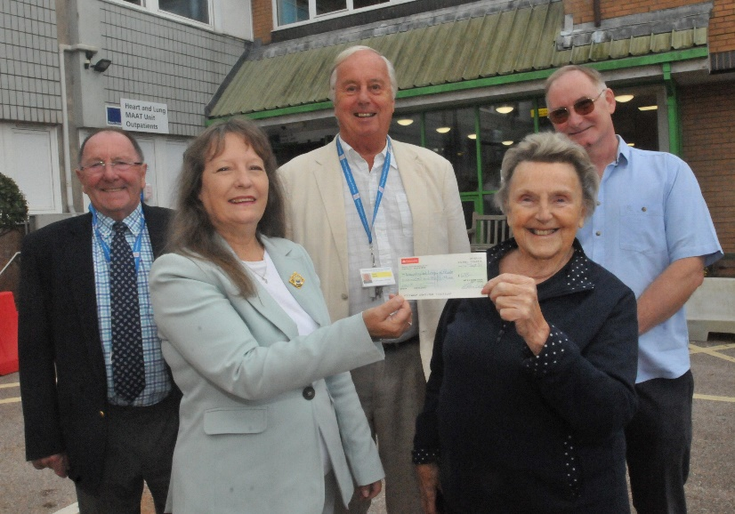
MEET THE TEAM
LINEN LEAGUE
I moved here from just north of Manchester in 1998, I had been used to helping and volunteering before I moved to Torquay, it was no surprise that when I met Rachel Evans I joined her group of Ladies known as The Linen League. Tuesday afternoons were spent in the Boardroom with our sewing machines. Rachel was the co-ordinator for these ladies, the Group being part of The League of Friends. Over the years I have been involved in making various items, all of which have been asked for by the wards. To mention a few - theatre gowns, under-arm cushions, syringe bags, ice pack covers, tabards, especially red ones for the Mealtime Helpers. Several years ago Rachel moved to Henley-on-Thames and I became the Co-ordinator. This entails having contact with the various wards, also purchasing any materials that were needed. Percy’s in Newton Abbot has been a lifeline for materials etc and served the Hospital for many years. All expenses are paid by The League of Friends which over the years has saved the Hospital money. I also attend the monthly Management meeting of The League of Friends where I report on what items have been distributed and progress that has been made. Originally meeting in the Boardroom, the Ladies now meet in rooms in the Kitson Buildings. Along with the Linen League ladies I have also been involved with making items for our pre Christmas stall with all monies going to the League of Friends. Needless to say, none of this has been able to carry on since March 2020 due to Covid restrictions but in September 2021 the ladies were back at their sewing machines looking forward to supporting the hospital. Another of my volunteering jobs has been with the Chaplaincy Team at the Hospital. Every Wednesday morning, I have visited Patients on the wards, having a chat and hopefully helping to cheer them up. During my free time I am a member of the Central Church and once a week I hold a preschool group, I enjoy playing the piano, walking and eating out with friends. During lockdown I kept myself busy knitting squares for the Leonard Stocks Centre and making cloth shopping bags for FACT. Barbara Lawton
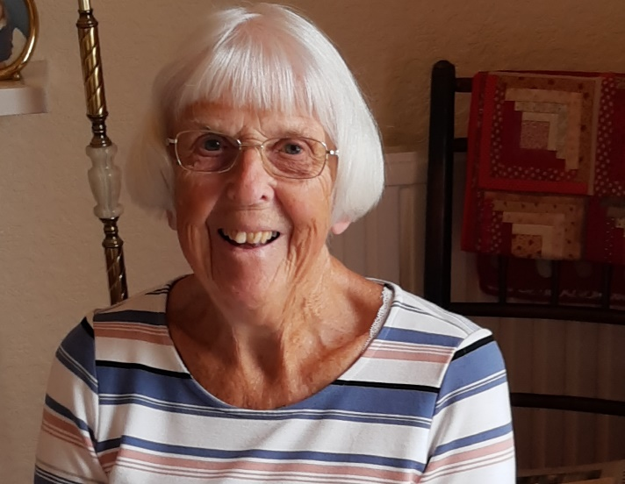
MESSAGE FROM THE CHAIRMAN
I feel honoured to be elected Chairman of Torbay Hospital League of Friends. We continue to work in challenging times but I am hopeful that over the next few months we will return to normality. Our new office and retail counter will be completed in March 2022. It will be constructed in the level 4 entrance area. We have provided the hospital with Bariatric stair climbers, Laparoscopic ultrasound equipment, Comfort packs for patients, and gift packs for front line staff. We will be providing medical equipment for the new Acute Medical Unit. This is our next large fundraising project. There have been no social events this year but we hope to resume some activities in the Spring. Thank you all for supporting us this year and we hope to see you on Level 4 in November and December. Yours sincerely, Mr Roy Tuttle
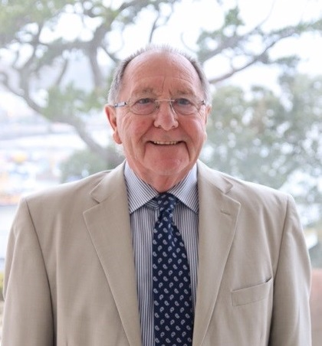
MESSAGE FROM OUR PRESIDENT
Having lost our café and shop on level 2 we do seem to be in limbo at present. However, being optimistic we are hopeful that we will be having a presence on level 4 main entrance when the extensive building at the hospital progresses further. We are still supporting the hospital, as we have for over 60 years, purchasing equipment and supporting projects which would not to be funded by NHS, So, any donations are gratefully accepted, and we can guarantee that any money will be used for the benefit of patients and staff. Patricia Robert
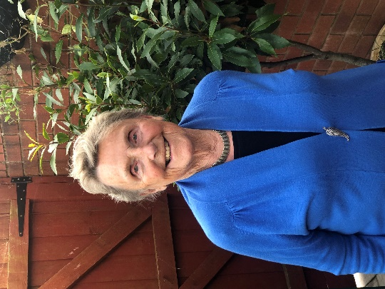
ULTRASOUND MODEL TO TRAIN SURGEONS
Ultrasound model to train Surgeons £4690 Raised From across the UK funded by Torbay Hospital League of Friends
South Devon Upper Gastrointestinal (GI) Unit is extremely proud to start using a new ultrasound model, made possible thanks to the generosity of Torbay Hospital’s League of Friends The laparoscopic bile duct ultrasound model will be used for training surgeons from around the UK in this technique. The advanced model replicates body tissue and allows highly realistic training to be delivered. Laparoscopic bile duct ultrasound improves both patient care and efficiency in the management of gallstone disease. Over many years, South Devon Upper GI Unit has developed a national reputation for delivering high quality courses and forging the introduction of this new technology. The donation from the League of Friends will enhance the unit’s training offer and ultimately result in a better patient experience. Stuart Andrews, Clinical Director of Surgery at Torbay and South Devon NHS Foundation Trust, said: “This ultrasound model is an extremely valuable resource for training biliary surgeons in a new and effective technique, so the addition of this equipment will help surgeons improve patient care. We are extremely grateful for to Torbay Hospital League of Friends for making this possible with their kind donation.” Patricia Roberts, President of Torbay Hospital League of Friends, said: “High quality training of the next generation of doctors is essential so the League of Friends was proud to be able to provide this state-of-the-art training equipment. The donation will enable our hospital to build on the excellent reputation for training it already enjoys.”
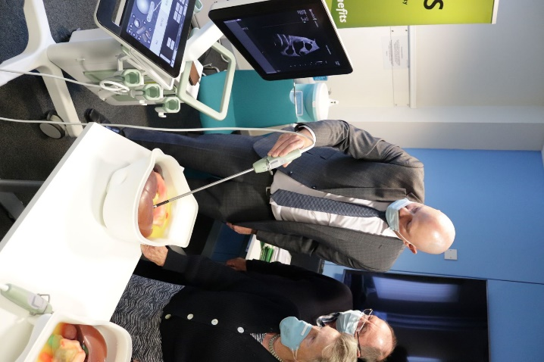
Torbay Hospital League of Friends fund Stair Climbers
Torbay Hospital League of Friends’ generous fundraising has paid for two stairclimbers, which will help people with limited mobility travel using patient transport. The two bariatric stair climbers will be used by Torbay and South Devon NHS Foundation Trust’s Patient Transport Services to ensure that people are safely helped up and down stairs and into vehicles. The stair climbers are specifically designed to help people with limited mobility. These will result in a more comfortable and easier journey for people who need help getting to and from hospital and healthcare sites for appointments and treatment. The CR230 stair climber produced by manufacturer AAT is able to support those who weigh up to 230kg, which is over 70kg more than the limit of the current equipment. Torbay Hospital League of Friends had previously supported Patient Transport Services by funding 11 stair climbers which are in place in all of the team’s double crewed ambulances. Louis Nicholls, Patient Transport Officer at Torbay and South Devon NHS Foundation Trust, said: “The new stair climbers will not only help our team to support people with limited mobility, but more importantly will allow us to be to offer a higher level of service for people across Torbay and South Devon which means the world to me.” We thank the kindness and generosity of the League of Friends and the massive support they have given us. It was brilliant to be able to show the League how the equipment is used every day, and it is great to know that they are there to listen to any ideas we have that will help the community. “This type of equipment helps our organisation continue to provide quality care to the people of Torbay and South Devon, so a big thank you to everyone who has kindly supported the League of Friends to help bring this and other initiatives to fruition.” Roy Tuttle, Chairman of the Torbay Hospital League of Friends, said: “We can all imagine how difficult it would be to transport a sick or injured person to and from hospital when several flights of stairs are involved. We were delighted to be able to help Patient Transport Services to acquire two fantastic bariatric stair climbers which we know will make the patients journey less stressful and, at the same time, make the job of everyone in patient transport a little bit easier.”
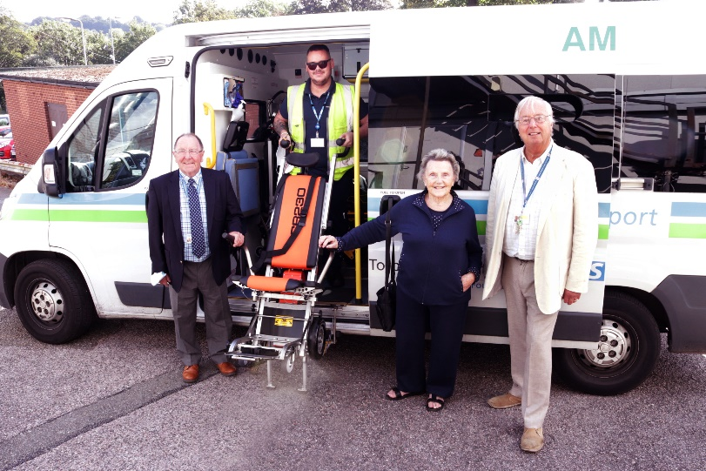
TWO PAEDIATRIC VENTILATORS FOR THE HOSPITAL’S EMERGENCY DEPARTMENT
Torbay Hospital League of Friends has funded two paediatric ventilators for the hospital’s Emergency Department which will help the team provide lifesaving ventilatory support. This type of ventilator is the only device available that can be used for all age groups; from neonatal to adults. It also offers many different types of ventilation modes suitable for children of all ages. A certain number of children who need ventilation may also require time-critical transfer to specialist centres (e.g. Bristol, Plymouth, London). The ventilators are also portable to support these time critical transfers. The same type of equipment is also used by dedicated children’s hospitals and the critically ill children’s transport team, which means the transfer process becomes more seamless and helps us provide the highest quality care possible. We are exceptionally grateful to the League of Friends for this kind and generous donation which will enhance and further support the excellent care delivered in our Emergency Department. Roy Tuttle, Chairman of the Torbay Hospital League of Friends, said: “We all want the absolute best for our children, especially when they are sick and even more so when it’s an emergency. When we heard there was a need for this type of equipment we were more than happy to provide the necessary funds to enable the children’s Emergency Department at Torbay Hospital to acquire these brilliant ventilators to support critically ill children.” Two paediatric ventilators for the hospital’s Emergency Department £33,000

LEAGUE OF FRIENDS CHRISTMAS CARDS
We have our Charity Christmas cards in stock and they are great value at £4.00 per pack of 10 There are four scenes 2 from Torquay Harbour, Cockington and Brixham. Contact your local committee member on info@thlof.co.uk and we can arrange either collection, delivery or postage at £1.60 per pack or £3.20 for 2 packs or more
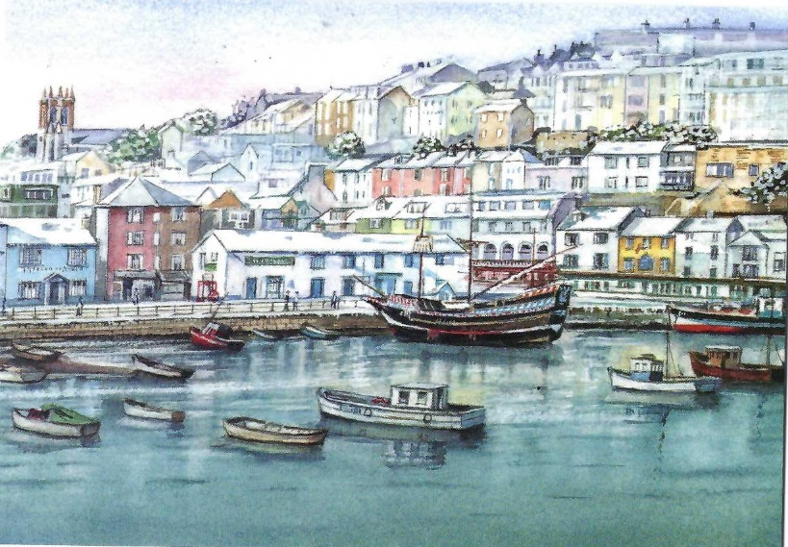
BRIXHAM COCKINGTON
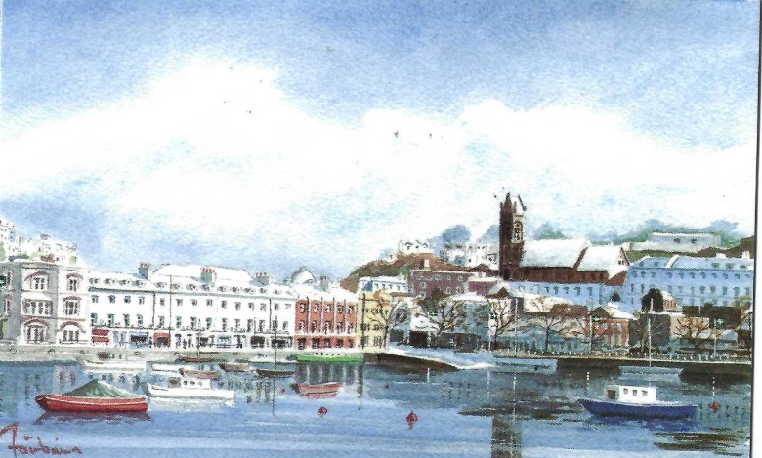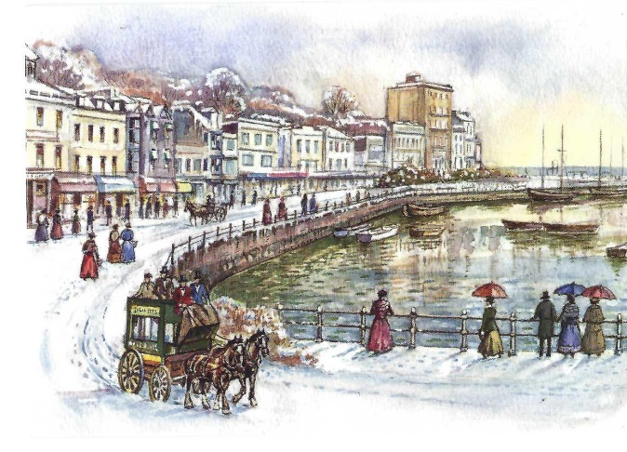
TORBAY

