APRIL 2021
When the League met the Prince
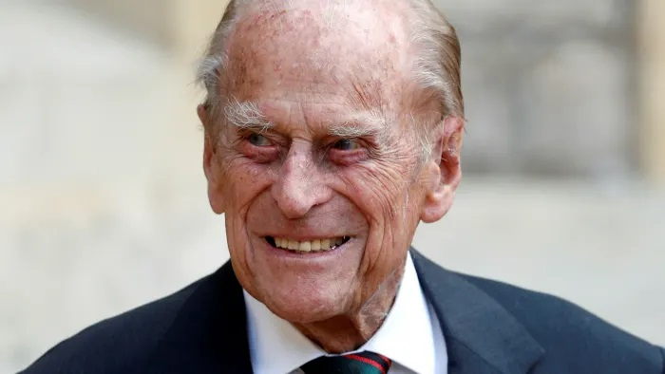
On Thursday 9th March 1978 His Royal Highness Prince Philip, Duke of Edinburgh made a visit to the Hospital and staff and volunteers were asked to line a corridor to meet His Royal Highness. One of the volunteers, who used to man the telephone trolley, was our current President Patricia Roberts and she remembers with fond memories the day we asked her what stood out about the meeting, “I was standing in line with other volunteers while the Prince came down the line and stopped at the lady next to me. He ask several questions and she nodded at him to which I leaned over and said “Excuse me Sir, I am afraid the Lady is deaf. He said thank you and moved on”
RIP Sir you have done your duty

NEW EMERGENCY / MRU
Due to Covid, the plans for the Emergency Department were brought forward and altered. The department needed to be expanded to allow for social distancing. A new Medical Receiving Unit (MRU) will be built on Level 2 and will incorporate the space previously occupied by the League of Friends and other offices and departments. Unfortunately, this means that the Butterflies Café, League of Friends office, and the guides area will no longer be available to us.
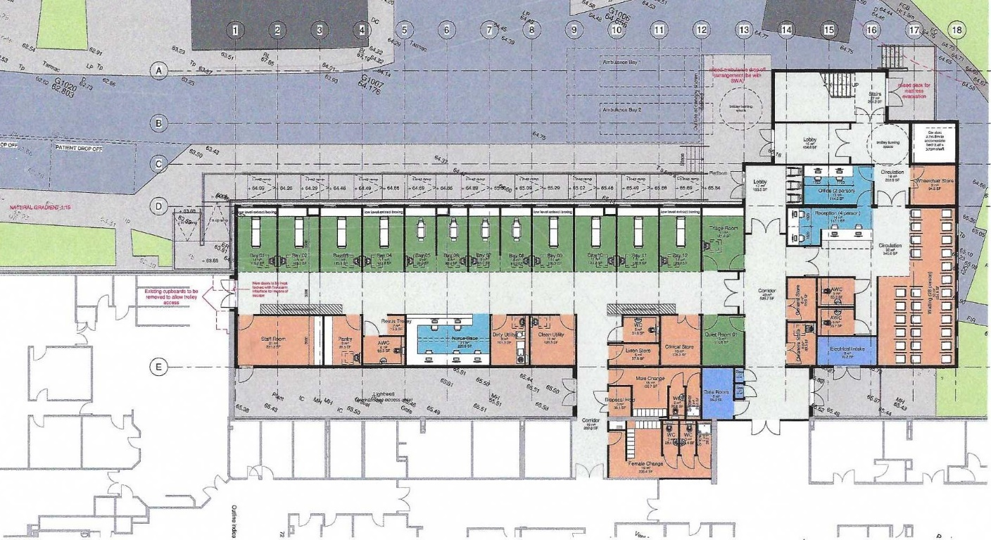
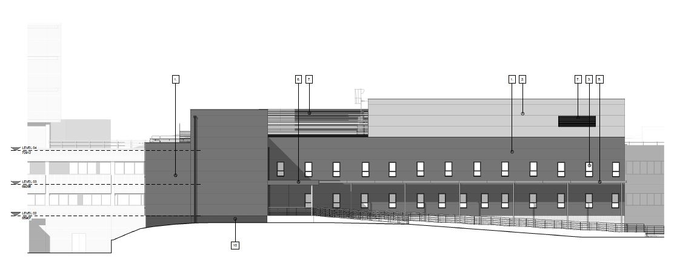
A socially distanced, groundbreaking ceremony has taken place at Torbay Hospital to mark the official start of construction on a new £15million Acute Medicine Unit (AMU).
Torbay and South Devon NHS Foundation Trust runs Torbay Hospital, and its Acute Medicine Unit is essential to reduce overcrowding in the Emergency Department.
The current AMU has 26 assessment spaces for patients, whereas the new facility will see this increase to 52 assessment spaces. The new unit will ensure that patients receive timely, high quality care, in the right place.
The exciting project will see the hospital receive a modern and fit-for-purpose AMU which will be split over two levels. This will allow for patients with different levels of care to be treated in the most appropriate setting.
Kier (the appointed contractors) are now onsite with the building works anticipated to last for 12 months.
Liz Davenport, Chief Executive at Torbay and South Devon NHS Foundation Trust, said: “The construction of Torbay Hospital’s new Acute Medicine Unit will transform the delivery of care for both patients and staff. The new facility will help ensure that patients continue to receive a high level of care in the most appropriate setting, and I thank everyone involved in the project that has enabled us to get to this point.
“I look forward to seeing the developments progress over the next 12 months before we begin to see the benefits that this exciting development will bring for our patients, staff and visitors.”
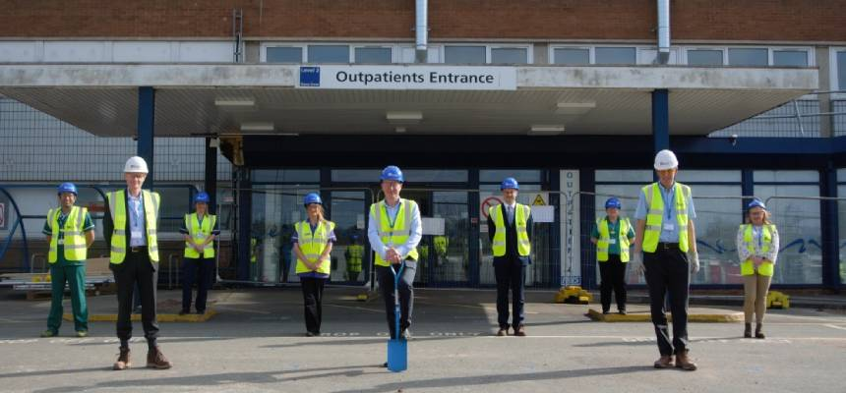

Torbay Hospital League of Friends has continued its fundraising efforts in spite of the challenges posed during the ongoing pandemic. Most recently, the League has approved expenditure totalling £69,823 to provide two bariatric stairclimbers, iPads for theatres, four trollies for the Catheter Lab and two additional children’s ventilators.
Two very generous legacies of £10,000 from the respective estates of the late Mr and Mrs Richards will benefit the Ophthalmology and Cardiology Departments.
The Ophthalmology team has been able to purchase special chairs for ophthalmic imaging equipment. The chairs are specifically designed with brakes on the back and high handles and electronic controls to raise and lower the patient to position. They significantly reduce the risk of patient falls and back-related health problems for staff. They are extremely manoeuvrable and have been well received by staff and patients alike.
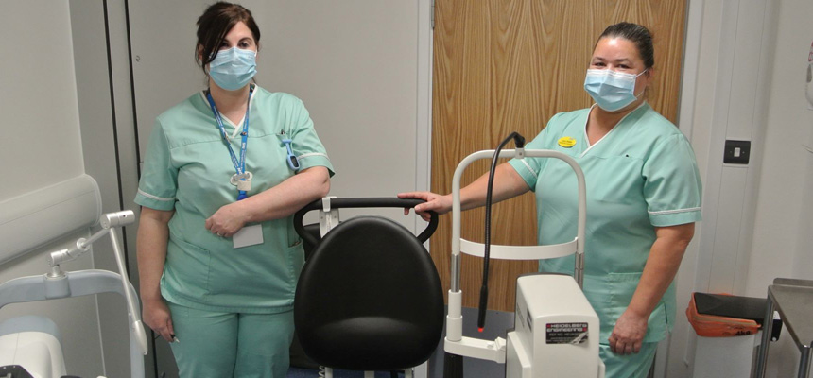
The Cardiology Department will benefit from two echocardiography clinic room couches, a handheld echocardiography device, two pacemaker trollies for the Cardiac Catheter Lab and a Genlab Classic Incubator for the Cardiac Catheter Lab.
A handheld echocardiography device is a clinical useful tool to allow rapid assessment of appropriate patients which will allow the doctor to perform an echocardiogram on the patient whilst undertaking a procedure within the Cardiac Catheter Lab. The two pacemaker trollies will allow for better storage of cardiac devices and components within the lab.
Additionally, the League is continuing to fund the provision of Cook and Eat Sessions for the Children and Young Person Diabetes Service, as well as committing £6,000 to Education Simulation. This helps provide teams who deal with patients in their own homes with a safe space to learn valuable skills in environments that are as realistic as possible.
Patricia Roberts, President of the League of Friends, said “Even though we have not been able to ‘get out and about’ over the last 12 months, we have not been sitting idle, and have been able to continue to provide substantial sums of money for all kinds of equipment requested of us by the Hospital.
“We were particularly grateful to the late Mr and Mrs Richards for their incredibly generous donations which I am delighted to say have been put to so much good in the respective departments they nominated. We are so grateful for people’s generous donations which enable us to direct support where it is most needed in our much-valued hospital.”
Liz Davenport, Chief Executive of Torbay and South Devon NHS Foundation Trust, said “We are so fortunate to have such an active and generous League of Friends at Torbay Hospital, as well as in all our community hospitals. Thanks to their fundraising efforts, we are able to benefit from extra equipment and updated facilities. It makes such a difference for our staff teams and for all the local people they support.
“I would also like to thank the members of the public who donate to the League and contribute to fundraising events as their generosity makes these donations possible.”

Birthday Request
In February 2021 Margaret Parken was looking forward to celebrating her forthcoming birthday yet she decided that instead of presents she would like to donation to the Torbay Hospital League of Friends. On her donation page she aimed at £150 yet when it closed it had raised £260 while some people missed the closing date and gave direct to the league donation, we are in the process of counting the final amount so watch this space for the total.

Pennies in Plastic
Since the start of the Pandemic Pennies in Plastic has been put on hold as firstly our office on level 2 needed to close which meant there was no drop of point for your pennies.
Soon we shall be able to start taking your pennies and we shall be notifying you of the new drop of point.
So start collecting again and remember we take all loose change including paper.

Mobile Request
In March of 2021 we received a request from Children’s Emergency Department if we could for purchase 2 mobile ICU Hamilton Ventilators for the Paediatric Emergency Care to a cost of £34,233 to which we agreed.
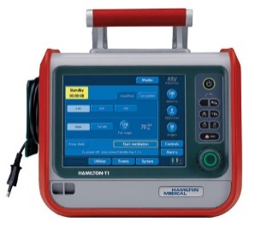

ANNUAL GENERAL MEETING 2021
Our long awaited AGM will be held by ZOOM, to all paid up members, on 13th May 2021 at 2.15pm. All members will be notified in due course of arrangements to join the meeting.

